Support Mechanism for Filling Key Knowledge Gaps for Vulnerable Species (Marine Mammals, Seabirds, Sea Turtles and Elasmobranchs) Impacted by Fisheries in Priority Areas of The Mediterranean

Financial Statement
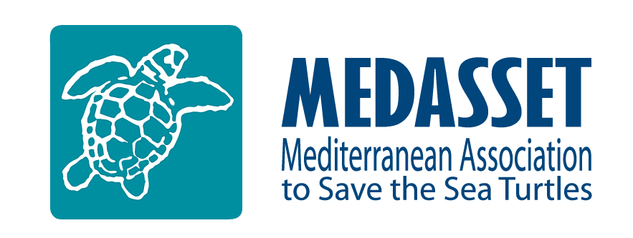
In Partnership with:

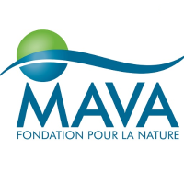
Financially supported by:

Summary

Please fill in this table with detailed information about the budget of your proposed project. Feel free to add other rows to the table according to your activities. all expenses should be converted to Euro based on a standard rate of the day the application was submitted
Activities of the project | Categories | Budget requested from SPA/RAC |  | Co-funding
 |  |  |  | (in-kind or from other sources)
 |  | Applicant | Partner | Applicant | Partner
 |  |  | (if any) |  | (if any)
Activity 1 | Personnel
 | (Please specify)
 | Non-consumable equipments (Please specify)
 | Consumables (Please specify)
 | Travel
 | (Please specify)
 | Field work
 | (Please specify)
 | Other
 | (Please specify)
Activity 2 | Personnel
 | (Please specify)
 | Non-consumable equipments (Please specify)
 | Consumables (Please specify)
 | Travel
 | (Please specify)
 | Field work
 | (Please specify)
 | Other
 | (Please specify)
Activity 3 | Personnel
 | (Please specify)
 | Non-consumable equipments (Please specify)
 | Consumables (Please specify)
 | Travel
 | (Please specify)
 | Field work
 | (Please specify)
 | Other
 | (Please specify)
Total
GRAND TOTAL

ORGANISATION’S DECLARATION AND STATEMENT

The applying candidate declare and agree that his organisation:
- Read, understood and agreed with the terms and conditions of the project explained in the ToR document.

- Submitted this statement with precise estimation and converted any currency into Euro based on a standard rate of currency exchange in the day of submission.

- Understand and agree to the project’s funding terms and conditions.

I, the undersigned, as the person responsible for this project and the representative of the applying organization, hereby certify that the information given in this file is true and correct and that I agree with the previous points

Name:

Position in the organisation:

Date and place:

Signature and seal

